Title of the paper in English

Title of the paper in Spanish

Name and surname of the author 1[1]*

Name and surname of the author 2[2]

**Abstract**

A single paragraph of 200 words minimum. For research articles, abstracts should give a pertinent overview of the work. The following style of structured abstracts, but without headings, is strongly recommended: (1) Background: place the question addressed in a broad context and highlight the purpose of the study; (2) Methods: describe briefly the main methods or approaches applied; (3) Results: summarize the article’s main findings; (4) Discussion: compare your findings with the literature; and (5) Conclusions: indicate the main conclusions, recommendations, and future research.

**Keywords:** List a minimum of 6 pertinent keywords specific to the article, other than those that make up the title and separated by semicolons. In papers based on case studies, provide the location (geographical keyword).

**Resumen**

It will contain the Abstract correctly written in Spanish. Articles presented in Spanish must be accompanied by the title translated into English, which will be set out below the title in Spanish. An abstract and keywords in English will be included after the “Resumen” and “palabras clave”.

**Palabras clave:** previous keywords translated into Spanish correctly, separated by a semi-colon.

1. Introduction

The subject analysed must be organised according to this structure, based on the IMRAD model. In this way the titles of the main sections are those that appear in this template.

This section may be divided into subheadings. The introduction should reproduce and carefully review the current state of the research field and and key publications duly cited. Please highlight controversial and diverging hypotheses when necessary. At the end of the section, define the purpose and the main objective of the work and its significance across the state of the art.

2. Methodology

This section may be divided into subheadings. If there is an area or case study, it should be clearly established and described in a broad context. Highlight why it is important at the local level. Likewise, maps are recommended for the geographical location. The sources used for the work must be listed and justified. The criteria and analysis procedures used in the research must be explained. The goodness of the choice of working method used for the research must be supported in relationship with others used in research with a similar theme (if applicable). Include citations of scientific studies that have inspired the methodology used.

3. Results

This section may be divided by subheadings. It should provide a concise and precise description of the experimental results, their interpretation, and the main innovation issues obtained from applied analysis. For this purpose, graphics and maps may be included to facilitate the presentation of the results obtained.

3.1. Graphic material

Only figures and tables should be used, which should be consecutively numbered as such (Figure 1., Table 1., etc.) and will appear in the paper in their corresponding place. Each must have a brief title at the top and its source will be cited below. If the figure/table requires explanatory text, this should be arranged as a caption below the figure and on a separate line before the source and/or elaboration. The source and/or elaboration should appear as follows:

* Indicate the source and then, if applicable, add “Own preparation” separated by a period and followed by a full stop.
* In the event of a table or figure prepared by the authors, state only “Own elaboration”, without the word "source”.
* If it is a photograph by the authors state: “Photograph by the authors” (without the word “source”).

Table 1. Title of the table

|  |  |  |
| --- | --- | --- |
| **Header 1** | **Header 2** | **Header 3** |
| Data | Data | Data |
| Data | Data* | Data |
| Data | Data | Data |

Tables and figures could have a footer

Own elaboration

Figures cannot occupy more than one full page, but tables can.

The authors must ensure that no intellectual property rights are infringed by any of the graphic material used in the text.

Figure 1. Title of the figure

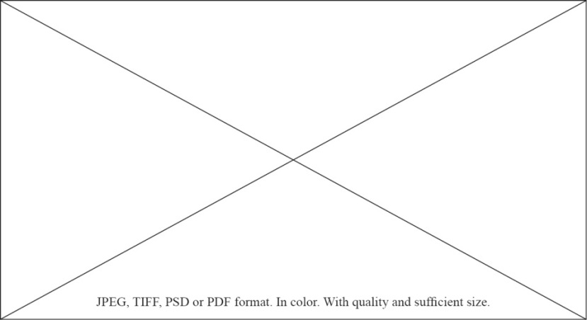

Source: Name of the source, year. Own elaboration (if applicable)

3.2. Citations

The APA style, 7th edition is used. You will find detailed information and examples at “Citations and references” in “**Citations and references”** section of the [Guidelines for authors](https://www.investigacionesgeograficas.com/user/setLocale/en_US?source=/directrices-autoria).

3.3. Other information of interest

You will find all the information of interest for writing the article at [Guidelines for authors](https://www.investigacionesgeograficas.com/user/setLocale/en_US?source=/directrices-autoria).

4. Discussion

This section may be divided by subheadings. Authors should discuss, support, and compare the results according to the existing literature (using references from similar studies) and how they can be interpreted in the light of previous studies and the working hypotheses. The findings and their implications should be discussed in the broadest context possible. Future research directions may also be highlighted.

5. Conclusions

This section presents the verification of the initial hypotheses posed in the research and provides a justification of the interest and novelty of the study for the subject analyzed or the scientific discipline from which it has been approached. This section must be worded clearly and precisely. When studies are approached on a local scale, based on case studies, conclusions should be offered to advance the general knowledge and facilitate application to other areas of study. This section should also offer a summary of the advancement represented by the research performed, its applied interest and possible lines of work to be developed in the future.

Authorship contribution

In the case of multiple authorship, the contribution of each author to the work should be specified according to the [Authorship Policy](https://www.investigacionesgeograficas.com/user/setLocale/en_US?source=/politica-autoria).

Funding

This section will necessarily specify the possible funding agencies and the code of the projects in the event that the article derives from research that has received funding.

Acknowledgments

This optional section may acknowledge any support not covered by the authorship contribution or funding. The type of collaboration should be specified.

Appendix

Is an optional section that can contain details and data supplemental to the main text. For example, explanations or details that would disrupt the flow of the main text, but nonetheless remain crucial to understanding and reproducing the research shown. All appendix sections must be cited in the main text.

References

The references should begin on a new page.

The style to be used is the APA style, 7th edition. You will find detailed information and practical examples in “**Citations and references”** section of the [Guidelines for authors](https://www.investigacionesgeograficas.com/user/setLocale/en_US?source=/directrices-autoria).

The journal does not publish studies with a high rate of self-citations.

Here are some examples:

**Book:**Surname, N., & Surname, N. (year). Title. Publisher. DOI or URL (if avaible).

**Book with edition or volume no.:** Surname, N. (Ed.). (year). Title (edition number ed., volume number vol.). Publisher. DOI or URL (if avaible).

**Edited book:** Surname, N. (Ed.). (year). Title. Publisher. DOI or URL (if avaible).

**Edited book chapter:** Surname, N. (year). Title of chapter, entry or contribution. In N. Surname editor & N. Surname editor (Eds.), Title of book (edition number ed., volume number vol., pp. xx‐xx). Publisher. DOI or URL (if avaible).

**Journal article:** Surname, N. (year). Title of article. Title of publication, volume(number), pp-pp. DOI or URL (if avaible).  
- Advance online publication**:** Surname, N. (year). Title of article. Title of publication. Advance online publication. DOI or URL (if avaible).  
- With missing information:If the journal does not use volume, issue or page numbers, omit the missing element(s) from the reference. If the journal article has an article number instead of a page range, include the word “Article” and then the article number instead of the page range.

**Newspaper article:** Surname, N. (year, Month day). Title of article. Title of Newspaper. URL (if avaible).

**Thesis and final projects:**  
- Unpublished: Surname, N. (year). Title of these/final proyect [Unpublished Type of thesis/work]. Institution that award the degree.  
- Published: Surname, N. (year). Title of these/final proyect [Type of thesis/work, Institution that award the degree]. Repository, file or database that hosts it. URL (if avaible).

1. Full filiation, Country author 1. Contact e-mail. Id orcid. * Corresponding author
2. Full filiation, Country author 2. Contact e-mail. Id orcid